

Zagazig University

Faculty of Computers and Informatics Computer Science Department

**Malaz, AI-powered mental health diagnostics and personalized alternative therapy recommendations.**

**BY**

1. Abdullah Mohamed Reda
2. Aya Mahmoud Abdullah
3. Aya Mohamed Mohamed
4. Basmalla Mohamed Saeed
5. Salma Elsayed Abdo

**Under Supervision Of**

**Dr. Mohamed Abdelbaset**

**2024-2025**

**Malaz, AI-powered mental health diagnostics and personalized alternative therapy recommendations.**

Abdullah Mohamed, Aya Mahmoud, Aya Mohamed, Basmalla Mohamed, Salma Elsayed

**____________________________________________**

**ABSTRACT**

Mental health does not just mean the absence of any mental illness. Mental health is the way we perceive our abilities, and bear the stresses of normal life. It affects the way we think, how we feel, how we act and how we make life decisions.

Mental health is an essential part of health and therefore an inherent human right, as mental illness accounts for 14% of the global burden of disease as a whole [1]. The most common mental illnesses globally are: depression, anxiety, mood swings, post-traumatic stress disorder, mania, drug abuse, and others.

Mental health problems are increasing worldwide, affecting people of all ages. Many individuals do not have easy access to mental health resources, which can make it difficult for them to understand their conditions and seek help. The significance of this project lies in its potential to bridge the gap between individuals and mental health support by providing an accessible solution to promote mental well-being. This project aims to provide a solution by developing a mental health application that helps users identify possible mental health disorders, understand their conditions, and find ways to improve their well-being.

The application has several key features. First, it offers a general test that screens 12 common mental health disorders, helping users recognize potential issues. It also includes a specialized test to determine if a user might be experiencing depression or bipolar disorder. Additionally, the app features a journaling section where users can write about their thoughts and feelings. An AI model analyzes these journal entries and provides helpful suggestions on how to improve mental health and mood.

Furthermore, the application includes a mood classification system that determines whether the user's emotional state is normal or indicates depression, based on their journal entries. This feature adds another layer of early detection, enabling timely awareness and support. The resources provided are continuously updated and include a variety of formats, such as articles, videos, and external links, to suit different user preferences and learning styles.

The project uses advanced AI technologies, including natural language processing (NLP) and sentiment analysis, to analyze user inputs and provide personal recommendations. The goal is to offer users a simple and accessible tool to self-assess their mental health and take actionable steps towards improvement.

This project is significant because it makes mental health support more accessible to everyone. By providing an easy-to-use, AI-powered solution, people can better understand their mental health, take proactive steps to improve it, and reduce the stigma around mental health by making reliable information and support accessible to everyone, encouraging proactive self-care, and empowering individuals to take control of their mental health journey.

1. **Introduction**

1.1 Introduction and Significance

Mental Health disorders are a growing global problem, affecting millions of people of all ages and backgrounds. According to the World Health Organization (WHO), depression alone affects more than 280 million people worldwide [2]. One in four people will experience a mental health problem at some point in their lives, yet many lack access to proper diagnosis, education, or support [3]. Stigma, limited resources and a shortage of mental health professionals exacerbate the problem, leaving people to face their struggles alone. Early identification and understanding of mental health conditions are critical to effective treatment and recovery but remain out of reach for many due to barriers such as cost, accessibility and lack of awareness.

In many parts of the world, the ratio of mental health professionals to the population is alarmingly low. For example, in low-income countries, there is an average of one mental health professional for every 100,000 people, compared to one for every 2,000 in high-income countries [4]. This shortage creates significant barriers to diagnosis and treatment, leaving millions without the care they need. Additionally, the COVID-19 pandemic has exacerbated mental health challenges, with studies showing a 25% increase in anxiety and depression rates globally during the first year of the pandemic [5].

This project addresses these challenges by developing a mobile application that empowers users to take control of their mental health. The app provides tools for self-assessment, education, and personalized emotional support, making mental health resources more accessible and user-friendly. By offering AI-driven screening tests and journal analysis, the app helps users identify potential mental health conditions, understand their symptoms, and receive actionable advice to improve their well-being. The primary objectives of this project are to:

* Provide an accessible platform for mental health screening and education.
* Use AI technologies to deliver personalized insights and coping strategies.
* Reduce stigma by encouraging proactive mental health management.
* Provide Resources that help users learn about mental health.

1.2 Contribution to Scientific Discovery

This project contributes to the mental health field by integrating artificial intelligence (AI) technologies to analyze user inputs and provide personalized mental health insights. The innovative use of natural language processing (NLP) and sentiment analysis allows for a deeper understanding of users' emotions and mental states based on their journal entries. One of the key innovations of this project is its use of machine learning models to analyze user data. For example, the app’s generalized mental health test screens for 12 common disorders, while specialized tests focus on conditions like depression and bipolar disorder. These tests are designed to be user-friendly yet scientifically grounded, providing results that can help users identify potential issues early on. Additionally, the AI-powered journaling feature represents a breakthrough in emotional analysis. By analyzing users’ written entries, the app can detect patterns in mood, identify emotional states, and generate tailored recommendations for improving mental well-being. This approach not only enhances user engagement but also provides a level of personalization that is rarely seen in existing mental health apps.

The application not only empowers individuals to take control of their mental health but also provides valuable data insights that can be utilized for further research in the field. The potential impact of this project extends to healthcare professionals, researchers, and organizations looking to enhance mental health services through AI-driven solutions. By leveraging anonymized user data, researchers can gain insights into mental health trends, such as how specific emotions or stressors correlate with certain conditions. This data can contribute to the development of more effective interventions and inform public health strategies. Furthermore, the app’s innovative use of AI and NLP sets a new standard for mental health technology, inspiring future advancements in the industry.

Moreover, the app’s design emphasizes user accessibility and inclusivity, ensuring that individuals from diverse backgrounds can benefit from its features. The interface is intuitive and easy to navigate, making it suitable for users with varying levels of technological literacy. By providing information in a clear and engaging manner, the app aims to educate users about mental health conditions, their symptoms, and available coping mechanisms. This educational aspect is crucial in combating misinformation and empowering users to make informed decisions about their mental health. Additionally, the app’s AI-driven personalization ensures that recommendations are tailored to each user’s unique needs, enhancing the overall effectiveness of the support provided. This combination of accessibility, education, and personalization positions the app as a valuable tool in the ongoing effort to improve global mental health outcomes.

**2. Related Work**

There are multiple technologies and applications designed to support mental health diagnosis, monitoring, and intervention. These systems primarily focus on self-assessment tests, mood tracking, AI-driven analysis, and therapeutic support to help individuals manage their mental well-being.

Many mental health apps offer self-assessment tests to help users identify potential psychological conditions. Applications like Mind Diagnostics and Mood path allow users to answer a series of questions to evaluate symptoms related to depression, anxiety, bipolar disorder, and other mental health issues. These tools rely on standardized questionnaires like the PHQ-9 for depression [6] and GAD-7 for anxiety [7], providing quick insights into a user's mental state.

AI technologies have been increasingly integrated into mental health applications. For example, **Wysa** [8] and **Replika** [9] utilize AI chatbots that engage in conversations with users to analyze their emotional states and provide coping strategies. These systems employ natural language processing (NLP) algorithms to detect keywords and emotional cues, enabling personalized mental health support. AI models can effectively identify signs of stress, anxiety, and depression based on text analysis and conversation patterns.

Apps like **Daylio** [10] focuses on mood tracking, allowing users to record their emotions daily. Some of these applications incorporate simple data visualization tools to help users identify mood patterns over time. Additionally, integrating journaling features with AI analysis can provide deeper insights. For instance, AI can analyze journal entries to detect negative thought patterns and suggest personalized recommendations to improve mental health.

Advanced systems leverage emotion detection algorithms to understand users' mental states better. These technologies analyze text, voice, or facial expressions to determine emotions such as sadness, anger, happiness, or fear. For example, emotion AI models can process written content to identify emotional cues, providing valuable feedback for therapeutic interventions.

**Limitations of Existing Solutions:**

While these methods are effective in specific contexts, they often have limitations. Many mental health apps focus on either assessment or mood tracking without integrating both features comprehensively. Additionally, existing solutions may lack personalization, cultural relevance, or accessibility for diverse user groups, especially in regions with limited mental health resources.

Our mental health app addresses these gaps by combining self-assessment tests, AI-driven journaling analysis, and emotion detection into a single platform. This integrated approach aims to provide comprehensive mental health support, personalized recommendations, and increased accessibility for individuals seeking to understand and improve their mental well-being

1. **Software Description**

3.1 Software Architecture (Figure 1)

The architecture of **MALAZ** is designed to be modular, scalable, and user centric. It follows a three-tier architecture consisting of the Presentation Layer, Application Logic Layer, and Data Layer. Below is an overview of the system architecture:

1. **User Interface (Frontend):**

This layer includes the user interface (UI) that users interact with. It is built using Flutter to ensure cross-platform compatibility (IOS and Android).

Key components:

* Users interact with the mobile app
* Login/Signup Module
* Mental Health Test Interface
* Journaling Interface
* Resources Interface

1. **Backend Server (Flask API):**

This layer handles the core functionality of the app, including AI-driven diagnostics, journal analysis, and personal recommendations.

Key components:

* Connects the frontend with AI models and the database.
* Mental Health Test Engine: Processes user responses to provide preliminary diagnoses.
* AI-Powered Journal Analysis Module: Uses NLP to analyze journal entries and detect emotions.
* Recommendation Engine: Generates personalized coping strategies based on user data.
* Authentication and Authorization: Manages user access and data security.

1. **AI Models**

* Analyze test responses to detect mental health conditions.
* Perform sentiment and emotion analysis on journal entries.

1. **External Services**

* Firebase for authentication and notifications.
* Azure and Railway for Cloud Storage

1. **Database (Mongo DB):**

This layer manages data storage and retrieval.

**Key components:**

* User Data Storage: Stores test results, journal entries, and user preferences.
* Mental Health Knowledge Base: Contains educational resources and information about mental health conditions.
* Cloud Storage: Hosted on Microsoft Azure or Railway for scalability and reliability

**Figure 1**

**3.2 Tools and Technologies Used**

The following tools, frameworks, and technologies were used in the development of MALAZ:

**Frontend Development:**

**Flutter:**

* Chosen for its cross-platform capabilities, allowing the app to run seamlessly on both iOS and Android.
* The Flutter app acts as the main interface for users. It lets them log in or sign up, update their account settings, and interact with the app's features. It connects with the backend using HTTP requests, receives responses, and shows the results to users. It also manages notifications sent through Firebase.

**Backend Development:**

* Python: Used for AI and machine learning components due to its extensive libraries and frameworks.
* The Flask API handles the app's core logic. It manages things like user authentication, account settings, and communication with the machine learning models. It sends secure tokens to keep user sessions safe, interacts with the database to fetch or update user information, calls the ML models for processing data, and triggers push notifications via Firebase.
* Create an API for each ML model to easily interact with it.

**AI and Machine Learning:**

* Machine Learning Models: Built using TensorFlow and Scikit-learn for diagnostic testing and recommendation generation.
* Natural Language Processing (NLP): Implemented for sentiment analysis and emotion detection.

**Database and Cloud Services:**

* MongoDB: Chosen for its flexibility in handling unstructured data, such as journal entries and test results.
* MongoDB is where the app's data lives. It stores user details, login histories, ML model outputs, and account settings. The Flask API reads from and writes to this database to keep everything up to date.

**Other Tools:**

**Firebase Cloud Messaging:**

* Firebase handles notifications for the app. Whenever something important happens, like the ML model finishing a task or account changes, it sends a notification directly to the user's device, as requested by the Flask API.

**Git/GitHub**:

* For version control and collaborative development.

**Microsoft Azure/Railway Servers:**

* Servers where the backend is hosted for production. It ensures the Flask API is always accessible and can handle user traffic reliably. It’s also set up with GitHub to streamline updates and make deployments smoother

**Why Were These Tools Chosen?**

Flask→ Lightweight, scalable, and easy to integrate with AI models.

Firebase → secure authentication and real-time notifications.

AI Models → Provides automated analysis of mental health conditions.

Flutter → Single codebase for Android and iOS apps.

Python → chosen for its robustness in AI and machine learning tasks.

MongoDB and AWS/Google Cloud → selected for their scalability and ability to handle large volumes of data securely.

**3.3 Software Functionalities**

MALAZ offers the following key features and functionalities:

1. **Mental Health Tests**

* Users can take two types of tests:
  + General Test: Screens for 12 common mental health conditions.
  + Specialized Test: Diagnoses depression, bipolar Type-1, or bipolar Type-2
  + Results are stored in the user profile to track mental health progress over time.

1. **Journal Analysis with AI**

* Users can write journal entries, which are analyzed using NLP to detect emotions and provide personalized recommendations.
  + AI analyzes text sentiment and suggests mental well-being tips.
  + Contribution to Problem-Solving: Provides users with early insights into their mental health, enabling timely intervention.
  + AI analyzes text sentiment and classifies the emotional state as either normal or depressed, then suggests mental well-being tips accordingly.

1. **Resource Repository:**
   * Offers educational content, including helpful links, videos, and coping strategies for various mental health conditions.
   * Contribution to Problem-Solving: Empowers users with knowledge and tools to manage their conditions effectively.
   * Content is regularly updated based on emerging research and user feedback to ensure relevance and accuracy.
2. **Secure Data Storage:**
   * User data is encrypted and stored securely in the cloud.
   * All communications are secured using HTTPS, and sensitive data is protected using encryption standards compliant with industry best practices.
3. **User Authentication & Profile Management**
   * Secure login using Firebase Authentication + JWT.
   * Users can update personal information and track history.
   * The profile section also includes test history and emotion tracking data.
4. **Notifications & Reminders**
   * App sends reminders for users to take mental health tests periodically.
   * Encourages users to write journal entries regularly
   * Personalized notifications are based on user activity and emotional trends to maximize engagement and support.
5. Contact-Us
   * Allows users to reach out for support, provide feedback, or ask questions.
6. Profile Editing
   * Users can update personal data such as name, gender, bio, and profile picture.
   * Ensures the user’s information is always up-to-date and personalized
7. **Methodology**

**4.1 Data Collection and Preprocessing**

Our mental health App is divided into two Characteristics diagnosing and treatment using Alternative therapy.

Datasets used for diagnosing:

The first dataset used is “**General Test**”[11] This data includes various symptoms for a range of 12 mental disorders 'MDD', 'ASD', 'Loneliness', 'bipolar', 'anxiety', 'PTSD’, ‘sleeping disorder', 'psychotic depression', 'eating disorder', 'ADHD', 'PDD', 'OCD'. It has 29 Different feature such as panic, breathing rapidly, sweating, trouble in concentration, having trouble in sleeping, having trouble with work, hopelessness, anger, over react, change in eating, suicidal thought ,feeling tired, close friend, social media addiction, weight gain ,introvert ,popping up ,stressful memory, having nightmares , avoids people or activities, feeling negative, trouble concentrating, blaming yourself, hallucinations, repetitive behavior , seasonally, increased energy .With total of 7000 entries Concentration in a Comma Separated Value (CSV) format.

Preprocessing of data: First, we cleaned the dataset by removing the nan values and removing duplicates. Second, the diagnose column is a string value so we mapped them into integers to feed them into the model. Third, we did correlation matrices for column to find which column affects the diagnosing and which not as a result we removed the age column. Finally, we converted the Pandas data frame to NumPy array before feeding it to the model.

The second dataset used is a Collection of 120 Psychology Patients with 17 Essential Symptoms to Diagnose Mania Bipolar Disorder, Depressive Bipolar Disorder, Major Depressive Disorder, and Normal Individuals. [12]The dataset contains the 17 essential symptoms psychiatrists use to diagnose the described disorders. The behavioral symptoms are considered the levels of patients Sadness, Exhaustless, Euphoric, Sleep disorder, Mood swings, Suicidal thoughts, Anorexia, Anxiety, Try-explaining, Nervous breakdown, Ignore & Move-on, admitting mistakes, Overthinking, Aggressive response, Optimism, Sexual activity, and Concentration in a Comma Separated Value (CSV) format. The Normal category refers to the individuals using therapy time for specialized counseling, personal development, and life skill enrichments. While such individuals may also have minor mental problems, they differ from those suffering from Major Depressive Disorder and Bipolar Disorder.

Preprocessing of data: First, we cleaned the dataset by removing the nan values and removing duplicates. Second, the diagnose column is a string value so we mapped them into integers to feed them into the model. Third, we used the One Hot Encoder to convert string columns into multiple columns with integer values. Also, we used Feature extraction to extract the top 10 features. Finally, we converted the Pandas data frame to NumPy array before feeding it to the model.

The third dataset used is an NLP data [13] which classifies the text of the user whether he is depressed or not. The data consists of two columns. The first one is the text of the user which is a statement he writes (example: I do not feel anything anymore) the second column is the label of the sentence whether the user us depressed or Normal. The data is 31755 entries and Concentration in a Comma Separated Value (CSV) format. This data was generated from another data contains a lot of symptoms. We started by extracting the depression and Normal labels then we started to augment the data using **Wordnet** to generate more sentences we also used **google translator** library to write new sentences in English like the other sentences and random library to extract random words from each sentence to generate new ones.

**Preprocessing of data**: We started by checking the null values the data did not contain any. Also, we checked for duplication value and the data was totally unique values. After that we removed the stop words, emojis, commas and any special character that may affect the understating of the sentence. Then we used **LabelEncoder** to convert string labels to numerical value. After that we started to tokenize, the data using **TfidfVectorizer** is a method that breaks text into smaller parts for easier machine analysis, helping machines understand human language. The last step was using SMOTE which is a statistical technique for increasing the number of cases in dataset in a balanced way. This solves the imbalance problem and then we split the data into the train and test data to feed it into our model.

**4.2 Model Development**

Models used for diagnosing:

First Model: The model used for diagnosing the general test data is a Random Forest Classifier. A random forest is a meta estimator that fits several decision tree classifiers on various sub-samples of the dataset and uses averaging to improve the predictive accuracy and control over-fitting. We started with trying the default hyperparameters of the model (**n_estimators**=100**,**\***, criterion**='gini'**, max_depth**=None**, min_samples_split**=2).It results in 94% Accuracy. After that we tried GridSearchCV it is a technique where we try every possible combination of hyperparameters then we used (grid_search_rf.best_params_ ) to find hyperparameters with highest Accuracy using this techniques results in 96% Accuracy.

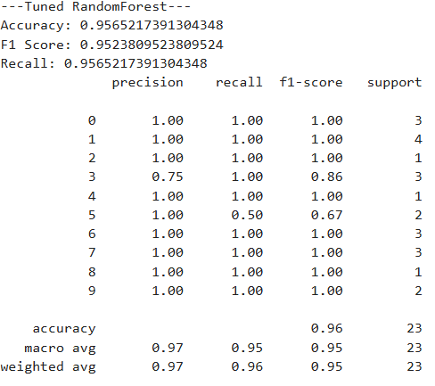

**Second Model**: The model used for this data is Logistic regression. Logistic regression is a statistical method that is used for binary classification. It is a linear model that predicts the probability of an observation belonging to a specific class. The data is preprocessed by scaling the features and converting categorical features into one-hot encoded vectors. Logistic regression has several hyperparameters such as Regularization to prevent overfitting, Solver (how the optimization problem is solved), **C**(controls the strength of the regularization penalty) and Max Iter. At first, we set these values to default resulting in 86% Accuracy. So, grid search is performed to find the best hyperparameters for the logistic regression model. Also, we used feature extraction techniques to extract most important features using SelectKBest function.

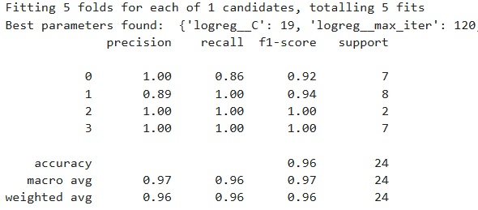

Third Model: The model used for this data is Logistic regression. Logistic regression is a statistical method that is used for binary classification. It is a linear model that predicts the probability of an observation belonging to a specific class. Logistic regression has several hyperparameters such as Regularization to prevent overfitting, Solver (how the optimization problem is solved), **C**(controls the strength of the regularization penalty) and Max Iter. We used The default values of the model which arepenalty='l2', *,C=1.0 ,solver='lbfgs' and max_iter=100. This results in 94% Accuracy for this model.

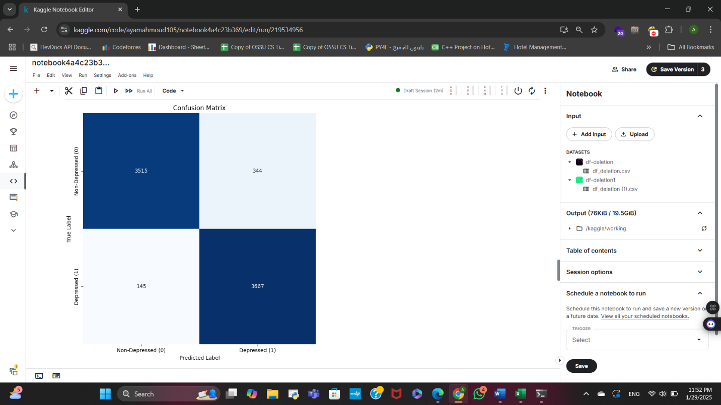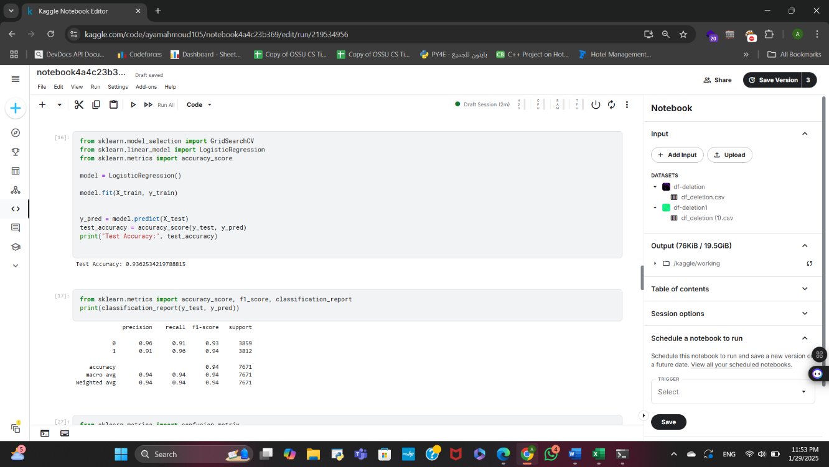

**4.3 Implementation**

1. After we finished collecting datasets, we started developing ML Models that will be used in diagnosing. The first model is the Random Forest classifier, and the second model is Logistic regression classifier. Third model is Logistic regression classifier. We used python language, Scikit learn library for models and Jupyter as our environment.

2. Second step was deploying the model and make its APIs using python and Flask Api. We used python to write the code for deploying this includes importing saved models and writing Function for prediction new entries.

3. Third step was designing the App’s UI using Figma. The APPs contain screens for APP.

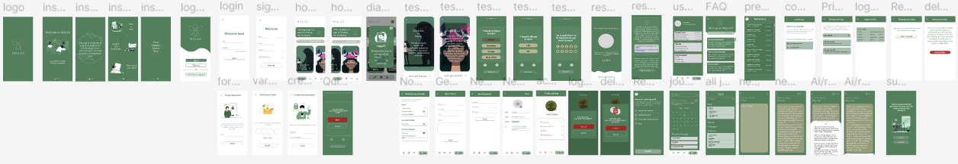

4. After Approving APP’s UI and its functionalities we started implementing the App using flutter to make our App cross platform. At the same time we developed [APP’s APIs](https://documenter.getpostman.com/view/37886768/2sAXjF8ZxB#9ff1a323-ca6d-464a-9fdf-509fb013d763) for login, signup….etc. We also made the Apps database using MongoDB database for user data ranging from personal information, tests data and Journal data.

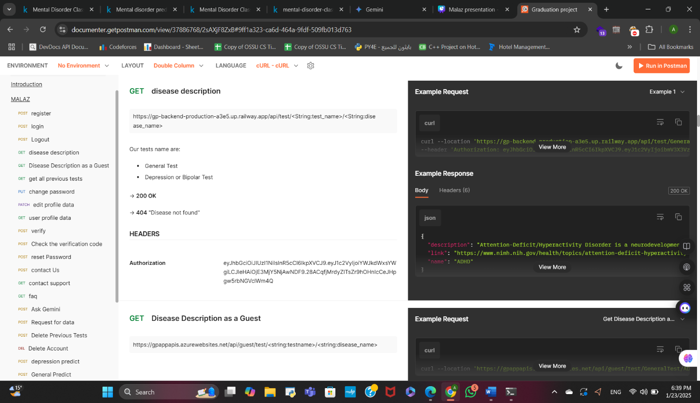

5-Our last step was implementing APP itself using flutter to make above screens and to integrate APIs and make it ready to use.

1. **Results and Discussion**

**5.1 Model Performance**

**Ai models** are the core of our intelligent application. The whole app relies on the accuracy of models to diagnose and treat our users. Tests model are Random Forest and Logistics classifiers both with accuracy of 96%.NLP models Logistic with 94 Accuracy.The table below shows each model with its croosponding results.

|  |  |  |  |
| --- | --- | --- | --- |
| Model name | Random forest Classifier (Diagnosing) | Logistic classifier  (Diagnosing) | Logistic classifier  (therapy) |
| usage | It is a model used for Diagnosing purpose | It is a model used for Diagnosing purpose | It is a model used for mood tracking |
| Accuracy | 96% | 96% | 94% |
| Precision | 95% | 95% | 91% |
| Recall | 95% | 94% | 96% |
| F1-Score | 95% | 95% | 94% |

**5.2 Interpretation of Results**

We can classify the results into 3 main areas:

* + - 1. Ai models.
      2. APP APIs and backend.
      3. Front work (Flutter APP).

**Ai models** are the core of our intelligent application. The whole app relies on the accuracy of models to diagnose and treat our users. Diagnosing Models are Random Forest and Logistics classifiers both with accuracy of 96%. Alternative therapy model (NLP model) is the logistic regression model with accuracy of 94% to diagnose whether user is depressed or not.

**APP APIs & Backend** to deal with communication between the frontend and the backend, including data storage, retrieval, and processing.

**Front work (Flutter APP)** which is responsible for providing a seamless and user-friendly experience and letting the user feel comfortable when taking test and feel satisfied as long as possible.

**Challenges** consistently raised when searching for datasets. For mental health, finding datasets that are accurate and huge is a difficult matter because of the diversity of illness, diagnosing techniques (there is no standard to classify the patient to a certain diagnosis) and lack of patient’s records.

1. **Illustrative Examples**

MALAZ provides reliable and validated tests designed to enhance users' understanding of their mental health. The application currently offers two comprehensive diagnostic tests:

1. **General Mental Health Test (Figure 1):** This test evaluates the user’s overall mental health and provides detailed information about specific conditions if the user wishes to learn more.
2. **Specialized Diagnostic Test (Figure 2):** This test determines whether the user is experiencing one of the following conditions: Normal mental health, Depression, Bipolar Type-1, or Bipolar Type-2. It also offers detailed explanations about these conditions to promote awareness and understanding.

MALAZ includes a secure database that stores **users’ test results**, allowing them to access their data for future reference (**Figure 3**). This feature ensures continuity and ease of monitoring progress over time.

The application also features a **Journaling Function (Figure 4),** where users can record their thoughts and emotions. MALAZ analyzes these entries to determine whether the user is experiencing depression or simply a temporary state of sadness. This tool promotes self-awareness and helps users track their mental health trends.

Additionally, MALAZ provides a rich repository of resources on various mental health conditions. These resources empower users to understand their conditions better, learn effective coping strategies, and recognize when professional medical intervention is necessary. The application aims to normalize mental illnesses by treating them with the same seriousness and care as physical diseases (**Figure 5**).

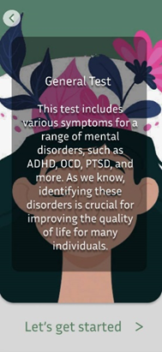

Figure3

Figure 222

Figuredf 1f hh22222k11kjk1

Figure5

Figure4

1. **Impact**

**7.1 Target Audience**

The application, MALAZ, offers a transformative way to diagnose and manage mental illnesses by leveraging advanced AI technologies. Designed for both doctors and patients, it provides a comprehensive understanding of various mental health conditions, including their definitions, symptoms, diagnostic criteria, and treatment options. Doctors can use the app to quickly and accurately diagnose mental health conditions, while patients can utilize it as a self-assessment tool. MALAZ addresses the rising demand for mental health support by providing two key diagnostic tests: a general test covering 12 mental health conditions and a specialized test diagnosing one of four cases—Depressed, Normal, Bipolar Type-1, and Bipolar Type-2. Additionally, the app features a journaling function where users can express their thoughts, allowing the AI to analyze the text and determine if they are experiencing depression. This dual functionality bridges gaps in mental healthcare accessibility and supports early intervention, ultimately improving patient outcomes.

**7.2 Innovative Aspects of the Design**

MALAZ integrates cutting-edge AI technologies to deliver a unique and impactful user experience:

AI-Powered Diagnostic Tests: The app uses machine learning models to analyze user responses and provide accurate preliminary diagnoses.

Journaling with NLP: The journaling feature employs natural language processing (NLP) to analyze users’ written entries, detect emotions, and generate personalized recommendations.

Dual Testing Framework: The combination of general and specialized tests ensures a comprehensive approach to mental health evaluation.

Resource Repository: The app provides educational content and coping strategies, empowering users to take control of their mental health.

These innovations improve upon existing solutions by offering a more personalized, accessible, and user-friendly approach to mental health management.

**7.3 Reliability**

MALAZ is designed to prioritize user accessibility and inclusivity. Its intuitive interface accommodates users with varying levels of technical proficiency, ensuring a seamless experience for both doctors and patients. The app’s first mobile approach makes it easy to download and use, enabling widespread access regardless of geographical location. This design philosophy ensures that mental health support is available to anyone with a smartphone, bridging gaps in mental healthcare accessibility and equity.

**7.4 Future research directions**

The development of MALAZ opens exciting opportunities for future research in mental health diagnostics. Potential areas of exploration include refining AI algorithms with additional patient data to improve diagnostic accuracy, developing predictive analytics for tracking disease progression, and investigating the correlation between environmental factors and mental health conditions. These advancements could further enhance the app’s capabilities and contribute to broader mental health research efforts.

**7.5 Added Value**

MALAZ makes a significant contribution to the field of mental health by providing an efficient, accessible, and precise tool for diagnosis and management. Its advanced AI capabilities enhance the understanding of mental health patterns, facilitate the early detection of conditions, and provide actionable insights for healthcare professionals. By streamlining the diagnostic process, MALAZ complements existing research and aids in the development of improved strategies for mental health treatment and care.

The integration of MALAZ into daily healthcare practice will revolutionize mental health diagnostics and treatment. Healthcare professionals will benefit from the app’s ability to accelerate the diagnostic process, enabling immediate interventions and the development of personalized treatment plans. Patients will experience a more proactive and supportive approach to mental health care, as the app empowers them to take an active role in their well-being. Overall, MALAZ enhances the efficiency and effectiveness of mental health services, leading to improved outcomes for individuals and a more streamlined healthcare system.

**7.6 Changes that will happen in daily practice**

The integration of MALAZ into daily healthcare practice will revolutionize mental health diagnostics and treatment.

* Healthcare professionals will benefit from the app’s ability to accelerate the diagnostic process, enabling immediate interventions and the development of personalized treatment plans.
* Patients will experience a more proactive and supportive approach to mental health care, as the app empowers them to take an active role in their well-being.

Overall, MALAZ enhances the efficiency and effectiveness of mental health services, leading to improved outcomes for individuals and a more streamlined healthcare system.

1. **Conclusions**

In this project "Malaz", we developed a mental health application designed to assist individuals in identifying potential mental health conditions, understanding their symptoms, and receiving guidance on recovery strategies. The app integrates multiple key features, including general psychological assessments, AI-powered journal analysis, and emotion detection, to provide users with valuable insights into their mental well-being.

Our system leverages AI and Natural Language Processing (NLP) to analyze users' journal entries, offering personalized feedback and mental health improvement strategies. The emotion detection model further enhances user experience by assessing emotional states based on journal entries, enabling more tailored recommendations.

This project has significant potential in the mental health sector, as it provides an accessible, AI-driven solution for self-assessment and mental health awareness. By leveraging advanced machine learning models and psychological evaluation techniques, we aim to bridge the gap between individuals and mental health resources, making mental health support more inclusive, efficient, and user-friendly.

Throughout the development process, we encountered challenges such as data accuracy, model bias, and user engagement. Addressing these challenges provided valuable insights into improving AI-driven mental health solutions. Future work may focus on expanding the range of mental health conditions covered, enhancing model accuracy, and incorporating real-time therapist interactions to further support users.

In conclusion, this project highlights the power of AI in mental health applications and paves the way for further advancements in AI-driven mental health support systems. With continued refinement and expansion, this system has the potential to make a meaningful impact on mental health accessibility and early intervention.

**9. Future Directions**

* Collect more accurate data to facilitate further testing.
* Investigate alternative diagnostic methods to improve the app's diagnostic precision.
* Incorporate peer and group therapy sessions.
* Adding educational features by providing articles and videos to raise user awareness about mental health**.**

**References**

[1]: <https://help.unhcr.org/egypt/en/health-services/mental-health/>

[2]: <https://www.who.int/news-room/fact-sheets/detail/depression>

[3]: <https://www.who.int/news/item/28-09-2001-the-world-health-report-2001-mental-disorders-affect-one-in-four-people#:~:text=One%20in%20four%20people%20in%20the%20world%20will,the%20leading%20causes%20of%20ill-health%20and%20disability%20worldwide>

[4]: <https://www.who.int/news/item/14-07-2015-global-health-workforce-finances-remain-low-for-mental-health>

[5]: <https://www.who.int/news/item/02-03-2022-covid-19-pandemic-triggers-25-increase-in-prevalence-of-anxiety-and-depression-worldwide>

[6]: <https://www.apa.org/depression-guideline/patient-health-questionnaire.pdf>

[7]: <https://castcentre.org/wp-content/uploads/2022/09/gad7_en-gb.pdf>

[8]: <https://www.wysa.com/>

[9]: <https://replika.com/>

[10]: <https://daylio.net/>

[11]: <https://www.kaggle.com/datasets/baselbakeer/mental-disorders-dataset>

[12]: <https://www.kaggle.com/datasets/cid007/mental-disorder-classification>

[13]: <https://www.kaggle.com/datasets/suchintikasarkar/sentiment-analysis-for-mental-health>

[14]: <https://github.com/Abdullah2O7/GP-Backend>

[15]: <https://github.com/Abdullah2O7/Model1-General>

[15]: <https://github.com/Abdullah2O7/model_3>

* **Articles**
  + <https://my.clevelandclinic.org/health/articles/24291-diagnostic-and-statistical-manual-dsm-5>
  + <https://pmc.ncbi.nlm.nih.gov/articles/PMC10800912/>
  + <https://pmc.ncbi.nlm.nih.gov/articles/PMC10546438/>